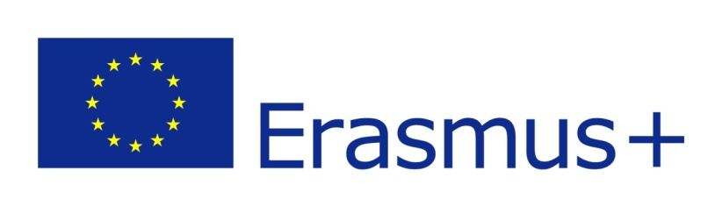

ERASMUS+
LETTER OF ARRIVAL
in the academic year 20…../20…..
Confirmation of Erasmus+ Training Period

This is to confirm, that (student’ name) _________________________
from Uniwersytet Przyrodniczy we Wrocławiu (PL WROCLAW04 )
is being hosted at our institution within the framework of the ERASMUS+ program.

Host institution:
Country:
Faculty/Department:
Name of the supervisor / Erasmus+ coordinator

Date of student’s arrival: ____________
Date of signature: _____________ ____ Signature

Official stamp

Please sign, stamp, scan, and send this confirmation by email to:
kamila.majchrzak@upwr.edu.pl

